Exploration into Robotic Motion, and Planning
Seth Campbell
TCSS 498 - Directed Reading
Advisor: Raghavi Sakpal

Introduction
Robotic manipulators move in space by solving a layered set of problems. Before a robot can navigate any given space it must know where it is given its joint positions, what joint positions does it need to get there, and how to get from here to there without issues? These correspond, in order, to forward kinematics, inverse kinematics, and motion planning. This paper surveys each of those in turn, grounding the math behind it to implement with the SO-ARM101 leader-follower arm system.
The SO-ARM101 is a six-degree-of-freedom (6DOF) robotic arm developed by the open-source community. Kits are readily available online for hobbyists and amateurs to set up their own robotic systems at home. Because this model is so popular there are several GitHub available that leverage Arduino and the manufacturer’s prebuilt libraries to bring your project to life. Instead, the choice was made to use ESPs and the ESP IDF for this project. This setup was chosen deliberately over pre-packaged libraries — partly to engage directly with the underlying protocols and partly because the implementation work itself forces a confrontation with the realities that the theory glosses over.
The primary reference used during this direct reading was Siciliano et al., Robotics: Modelling, Planning and Control (Springer, 2009), which provided the formal language and mathematical framework. Because of my familiarity with the reference, this paper mimics the primary reference’s structure: DH convention and frame assignment, forward kinematics via homogeneous transformations, inverse kinematics through both geometric and algebraic approaches, and motion planning from sampling-based to roadmap methods.

1. Denavit-Hartenberg Convention
Before any kinematic calculation is possible, there must be a consistent way to describe the geometry of a robot arm; specifically, the spatial relationship between each pair of adjacent joints. The Denavit-Hartenberg (DH) convention is the standard answer to that problem. It provides a systematic, minimal framework for assigning coordinate frames to each link in an open kinematic chain and expressing the transformation between consecutive frames using exactly four parameters.
The convention works by attaching a coordinate frame to each link, from the base (Link 0) to the end-effector (Link n), according to two strict geometric constraints. First, the x-axis of each frame must be perpendicular to the z-axis of the previous frame. Second, the x-axis must also intersect the previous frame’s z-axis. These constraints are not arbitrary, they are what allow the general six-parameter rigid body transformation between two frames to be collapsed into just four parameters, one of which is the joint variable itself.
For each pair of consecutive frames i-1 and i, those four parameters are defined as follows. The link length aᵢ (the distance between the z-axes of frames i-1 and i, measured along the common normal or xᵢ axis). The link twist αᵢ (the angle between those same z-axes, measured about xᵢ). The link offset dᵢ (the distance along zᵢ₋₁ between the two common normals). And the joint angle θᵢ (the angle between xᵢ₋₁ and xᵢ, measured about zᵢ₋₁). For a revolute joint, the only type used in the SO-ARM101, the only joint variable is θᵢ, and all other parameters are fixed constants determined by the physical geometry of the arm.
The role of each axis in the DH frame is given a strict definition. The z-axis of each frame is aligned with the axis of rotation of the associated joint — for a servo motor, this is the axis the shaft revolves around. The x-axis is the common normal, pointing along the shortest perpendicular distance between the current and previous z-axes. The y-axis is then determined by the right-hand rule. This assignment makes the relationship between consecutive frames computable through a fixed sequence of four elementary transformations: a rotation about z by θᵢ, a translation along z by dᵢ, a translation along x by aᵢ, and a rotation about x by αᵢ.
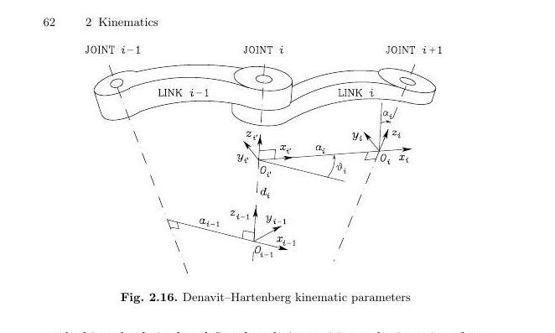
Figure 1. Denavit-Hartenberg kinematic parameters showing the geometric relationship between consecutive joint frames i-1 and i. The four DH parameters — aᵢ (link length), αᵢ (link twist), dᵢ (link offset), and θᵢ (joint angle) — fully specify the transformation. (Siciliano et al., Fig. 2.16)
Table 1 summarizes the four DH parameters.
Parameter | Symbol | Type | Description | SO-ARM101
Link Length | a | Constant | Distance between z-axes along x | Per joint geometry
Link Twist | α | Constant | Angle between z-axes about x | ~0 (aligned joints)
Link Offset | d | Constant | Distance along z between x-axes | ~0 (aligned joints)
Joint Angle | θ | Variable | Angle between x-axes about z | Servo position
Something that emerged during implementation was the distinction between the DH frame assignment and the coordinate frames embedded in the arm's Unified Robotic Description Format (URDF). The URDF describes each joint's position as an XYZ translation and its orientation as Roll-Pitch-Yaw (RPY) Euler angles, a full six-DOF transform placed according to the CAD geometry, which doesn’t follow DH conventions. To get from URDF to DH, the RPY values are first converted into a 3×3 rotation matrix, which combined with the XYZ translation assembles into a 4×4 homogeneous transformation matrix for each joint. That matrix describes where the URDF frame sits, but it does not have the specific structure of a DH transformation matrix, whose entries are fixed functions of the four DH parameters. The actual DH parameter values are extracted by comparing the two: the z-axis column of the URDF rotation matrix gives the joint's axis of rotation, the distance between consecutive z-axes along the common normal gives link length a, and the angle between them gives link twist α (see Figure 1). For the SO-ARM101, the joints connect along the x-axis between links, which means α and the link offset d are approximately zero across the assembly, simplifying the parameter table considerably. This was one of the more demanding aspects of the implementation: what initially seemed like a bookkeeping detail required a fundamental rethinking of how the transformation matrices were being assembled.

2. Forward Kinematics
Forward kinematics (FK) is the way to find a given point in space (usually the end-effector’s position) given a set of joint angles. For an open kinematic chain, that position is obtained by taking the product of the individual coordinate transformations for each link from the base to the end-effector. Each transformation describes the position and orientation of one frame relative to the previous one, and the product of all of them is the total transformation from the base frame to the end-effector frame.
The mathematical representation is a combined rotation and translation in three-dimensional space. This homogeneous transformation matrix is a 4×4 matrix that encodes a 3×3 rotation matrix and a 3×1 translation vector. For a frame i relative to frame i-1, this matrix takes the standard DH form derived by composing four elementary transformations. The upper-left 3×3 block of the result encodes the relative orientation; the upper-right 3×1 column encodes the relative position.
The direct kinematics equation for an n-joint open chain is then obtained as the sequential product of all individual transformation matrices from Link 0 to Link n:
T₀ⁿ(q) = A¹₀(q₁) · A²¹(q₂) · … · Aⁿⁿ⁻¹(qₙ)
The result is a single 4×4 matrix whose upper-left 3×3 block is the end-effector’s rotation matrix relative to the base frame, and whose upper-right 3×1 column is the end-effector’s position vector. Figure 2 illustrates the coordinate frames attached to each link and the successive transformations that compose to give the final pose.
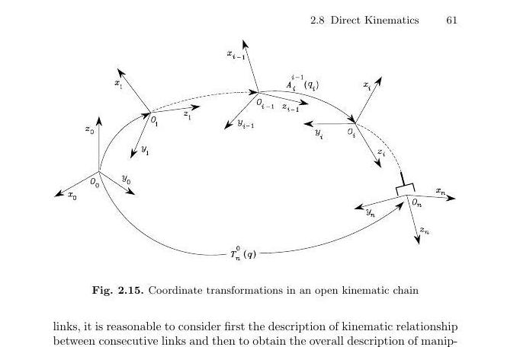
Figure 2. Coordinate transformations in an open kinematic chain from the base frame (Frame 0) to the end-effector frame (Frame n), computed as the sequential product of individual link transformation matrices. (Siciliano et al., Fig. 2.15)
For the SO-ARM101, the six revolute joints produce a 4×4 transformation matrix that is a function of six joint angles. Because the arm uses direct drive servo motors with no gear reduction, the relationship between commanded servo position and actual joint angle is 1:1, which simplifies translation between the kinematic model and the hardware control layer.
Implementing this in C++ required writing a class that handles sequential matrix multiplications without a linear algebra library, the standard library and ESP-IDF framework provide none. The Frame class stores the DH parameters and current joint angles; the Forward_K class orchestrates the products. An important architectural lesson concerns timing: when Frame data is simultaneously written by the ServoCommunication class and read by Forward_K, race conditions arise. The solution was to keep Frame and Forward_K separate from the communication pipeline, accepting a small latency rather than risking corrupted transforms.
The FK implementation as of this writing has correct orientation but magnitudes and signs are still incorrect. A rework of the approach to converting from the given URDF angles to the DH parameters is the next step.

3. Inverse Kinematics
Inverse Kinematics Inverse kinematics (IK) takes the opposite approach. It looks at what joint angle combinations will achieve a given end effector position. Unlike forward kinematics, which gives a unique answer for any joint configuration, inverse kinematics is more complicated. Multiple joint configurations can lead to the same end-effector pose, and some desired poses may not be reachable. For a six-DOF manipulator, a closed-form solution might not exist at all unless we make use of specific structural properties of the arm. The two main methods are geometric and algebraic. Each method has different tradeoffs in terms of computational cost, flexibility, and the number of solutions.
Geometric Approach and Kinematic Decoupling. The geometric approach works best when the manipulator features a spherical wrist, where the axes of the last three joints meet at a single point. In this case, the inverse kinematics problem splits naturally into two smaller problems. Inverse Position Kinematics (IPK) finds the joint angles for the first three joints to place the wrist center in the correct location. Inverse Orientation Kinematics (IOK) resolves the remaining three joint angles by treating them as interior angles of a triangle formed by the connecting links, which leads to a series of trigonometric calculations using the known link lengths. For the SO-ARM101, the geometric approach provides a straightforward route to a working implementation. It is computationally efficient since the main cost involves a few trigonometric evaluations instead of matrix inversion. The decoupling structure fits well with the arm’s physical geometry. However, its main limitation is specificity; the algorithm is designed for this particular kinematic structure and cannot be used for a different arm without going through the derivation process again.
Algebraic Approach. The algebraic method treats the IK problem as a set of nonlinear equations based on the direct kinematics function. For any end-effector pose represented as a 4×4 homogeneous transformation matrix, we invert the forward kinematics equation to find the joint angles. A key finding from Siciliano et al. is that for a six-DOF structure, a closed-form solution can only exist if three consecutive revolute joint axes meet at a common point (the spherical wrist condition) or if three consecutive axes are parallel. The algebraic framework also supports more general solution methods, including the Jacobian inverse and Newton-Raphson iteration, making it adaptable to cases where closed-form solutions do not exist.
Multiple Solutions and Selection. Both methods typically produce several valid solutions for a given end-effector position. For instance, a Stanford (anthropomorphic) arm with a spherical wrist could have up to four distinct configurations for a specific wrist position: shoulder-right/elbow-up, shoulder-right/elbow-down, shoulder-left/elbow-up, and shoulder-left/elbow-down. A separate selection algorithm is needed to choose from these options, often based on proximity to the current configuration, avoiding joint limits, or minimizing movement. Initially, we will use a nearest-neighbor selection criterion for the planned implementation.
Jacobian-Based Methods. The Jacobian matrix connects joint velocities to end-effector velocities and is crucial for understanding both kinematic singularities and numerical IK. In a kinematic singularity, a configuration where the Jacobian loses rank, the arm cannot move the end-effector in one or more directions no matter how the joints move. Near singularities, the Jacobian inverse can amplify small end-effector velocities into large joint velocities, which can create unstable motion. The Jacobian approach is fundamental for achieving smooth velocity-controlled movement; matching the speed of a servo, not just its position, requires linking end-effector velocity to joint velocity through the Jacobian. This insight connects the kinematic work to any future trajectory execution or vision-based control layer.

4. Planning Algorithms
Planning Algorithms Motion planning addresses the various paths provided by IK. It helps navigate from one configuration to another safely, avoiding obstacles. Planning operates above the kinematics layer, focusing on trajectories through the configuration space (C-space) rather than specific joint commands. The configuration space contains points representing every possible robot configuration. For the SO-ARM101, this is a six-dimensional space, with one dimension for each revolute joint. In C-space, it's useful to distinguish between C-free (configurations where the robot is clear of obstacles) and C-obstacle. The planning task is to find a path through C-free from a start configuration to a goal configuration.
Rapidly-Exploring Random Trees (RRT). RRT is a sampling-based algorithm that creates a tree by randomly sampling configurations in C-space and extending the tree toward each sample from the nearest existing node, as long as the extension remains in C-free. RRT is probabilistically complete; with enough time, it will find a solution if one exists. It also manages high-dimensional spaces well because it explores globally instead of relying on a precomputed map. Bi-directional RRT (RRT-Connect) grows two trees simultaneously, one from the start and one from the goal, attempting to connect them at the midpoint. This significantly cuts down search time and is the preferred method for the SO-ARM101, especially in future configurations where the arm works with a vision system for object sorting in a changing workspace.
Probabilistic Roadmap (PRM). PRM takes a different approach. Instead of building a tree at query time, it precomputes a roadmap of valid configurations and their collision-free connections during an offline phase. At query time, the start and goal points are connected to the nearest roadmap nodes, and the roadmap is searched for a path. This method is efficient for answering multiple queries against the same static obstacle layout. However, if the environment changes, the roadmap must be reconstructed. For the SO-ARM101, the environment is mostly static during a given run, making PRM appealing from a computational standpoint. However, since vision integration and machine learning are the ultimate goals, RRT’s flexibility is becoming more favorable.

5. Implementation on the SO-ARM101
Bringing these theoretical layers into contact with physical hardware reveals frictions that the formalism cannot fully anticipate. The SO-ARM101 implementation has proceeded in stages, and each stage has produced its own set of lessons.
Hardware and Communication Architecture. The SO-ARM101 uses Feetech STS-series smart servo motors communicating over a TTL half-duplex bus. Each servo has an internal controller handling PWM generation, position feedback, and EEPROM-stored parameters including position offset. The servo adapter board translates between the half-duplex TTL protocol and the full-duplex UART interface of the ESP32, and also manages power delivery: 12V for the servos and separate 3.3V/5V rails for the logic circuits. A second ESP32 in the follower arm communicates wirelessly with the leader over ESP-NOW, a lightweight peer-to-peer protocol requiring no encryption configuration. The full communication pipeline runs: servo position → TTL → servo adapter → UART → ESP32 (leader) → ESP-NOW → ESP32 (follower) → UART → servo adapter → TTL → servo position.
Configuring this pipeline required understanding the ESP-IDF project file structure and how the build system manages multi-device flashing. The most significant debugging challenge was an undocumented requirement in the servo adapter’s power circuitry: both the 3.3V and 5V input pins must be powered to activate the circuits for half-to-full-duplex conversion and signal timing. Hours of signal-path debugging ended when a reading of the electrical schematic revealed this omission. The ESP-IDF was chosen over simpler Arduino-based frameworks deliberately — it is oriented toward professional development and avoids the project-specific libraries that would obscure the underlying protocols. The cost of that choice was a steeper initial learning and setup curve.
Teleoperation and Calibration. The first milestone was teleoperation: mirroring the leader’s joint angles to the follower without any kinematic computation, primarily to verify the communication pipeline before adding more complexity. The main obstacle after establishing signal integrity was position offset calibration. Each servo stores an EEPROM offset defining a reference position; out of the box, the leader and follower offsets were inconsistent, so identical physical poses produced different position readings. The solution was to ensure a common reference between respective servos on each arm.
Forward Kinematics in Practice. The FK implementation reflects the rubber-meets-road experience documented in the later reflections. Transformation matrices are correctly structured, and the magnitudes of the output position vector are approximately right. The magnitudes are still incorrect and have odd signs: the computed z starts negative and degrades to a small value but not close to zero towards a full z axis extension of the frame.
Forward Path. With teleoperation established, the immediate next steps are to resolve the FK axis alignment issue and bring FK output online with correct coordinate assignment. The geometric IK implementation follows, after which the follower arm can accept an end-effector position as input rather than mirrored joint angles. The Jacobian-based velocity extensions and the motion planning layer are planned for a subsequent directed reading, contingent on reaching a stable FK/IK baseline with the current hardware.

Conclusion
During the direct reading I explored DH convention, frame assignment, forward and inverse kinematics, and motion planning. These are the basics of understanding the fundamentals of robotic motion. The DH convention makes it possible to represent the geometry of the arm compactly enough to compute. Forward kinematics converts that geometry into a usable description of where the end-effector is. Inverse kinematics inverts that computation to determine how to get where you want to go. And motion planning ensures that the path taken through configuration space is safe.
Working through these layers on physical hardware, rather than in simulation, makes several things concrete that the textbook treatment tends to obscure. The DH parameters cannot simply be read from a URDF file, they must be derived, and the derivation is sensitive to frame assignment choices that the convention leaves partially underdetermined. The homogeneous transformation matrices compose cleanly in theory; in practice, a single mistake in the projection matrix propagates through the entire chain. And the transition from teleoperation to FK-based coordination reveals how much apparent simplicity was an artifact of avoiding the kinematics altogether. The goal of the remaining work is to close the gap between what the formalism says should happen and what the hardware does.

References
Siciliano, B., Sciavicco, L., Villani, L., & Oriolo, G. (2009). Robotics: Modelling, Planning and Control. Springer.
Seeed Studio. (2024). SO-ARM101 Hardware Documentation and Servo Adapter Board Schematics.
Espressif Systems. (2024). ESP-IDF Programming Guide. https://docs.espressif.com/projects/esp-idf/
Feetech. (2024). STS Series Smart Servo Protocol Documentation.

